Lab 3 – (Part 1)

**Step 1:-** Lets first sync our local repository with Git, all coding at first will be done at local, and then later we will push it to Loki.

Windows user if you have downloaded gitBash, launch git bash, if not download <https://git-scm.com/downloads>. Mac users don’t need to install I will give more instructions in class we can use the terminal in Mac to run the git commands locally.

The reason why we are using Git bash is to make life easy for us, this process might look confusing at first but once we have the pipeline setup you will really enjoy it. The pipeline aims to write code once, sync everywhere.

**Step2:**- Now let's navigate to the folder locally, where we have our previous labs,i.e. the CIST1300-001 folder in your git bash.

If you can’t find it in your computer, don’t worry we have the version control and you can now realize how powerful Git is. Lets login to git lab and get your project URL from the home page and in your Gitbash type the below Unix command.

Unix Command - git clone <https://gitlab.com/sriramsrinivas/CIST1300-001.git>

Don’t use my URL after git clone, use the one which you have created, you can find it in gitlab, please see the screenshot below.

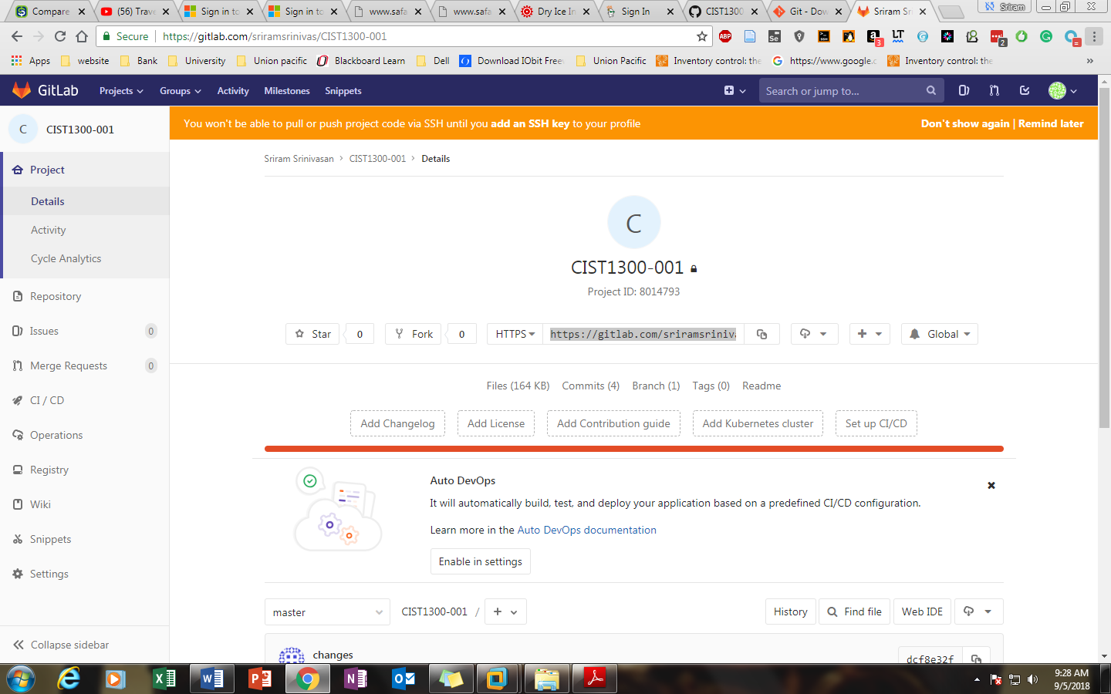

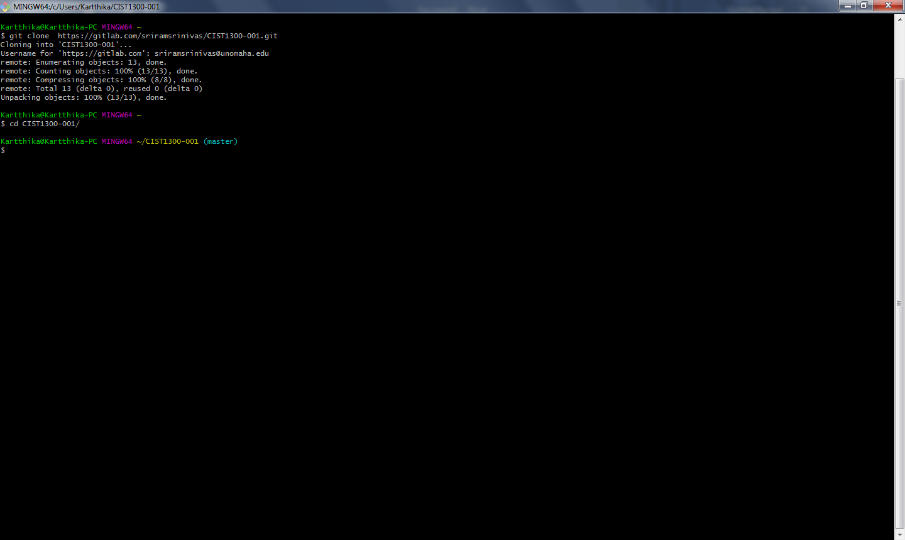

**Step 3:-** Once you have navigated to a CIST1300-001 folder or you have cloned in your local repository, let's make sure we can see Labs folder and see our previous Lab folder.

Unix Command:- ls

You should see something like this-

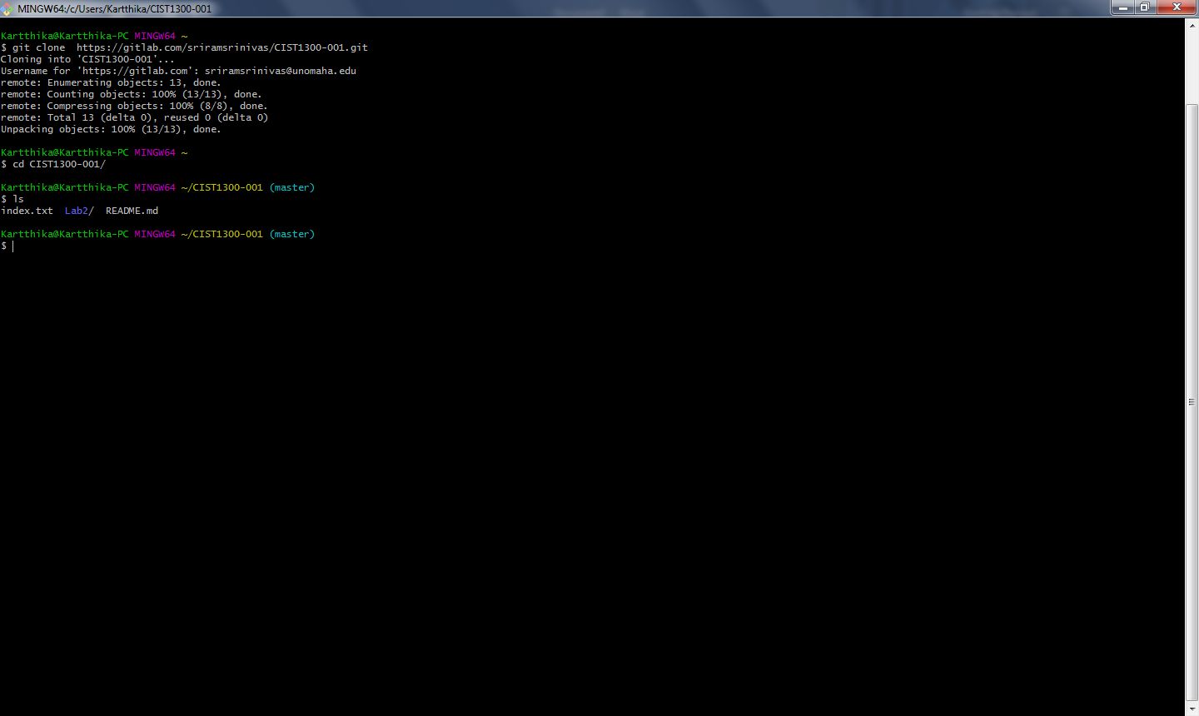

**Step 4:-**  Now let's create a Lab3 folder, make sure there are no spaces between Lab3 and L is caps. Few students had issues in the previous lab by having space between lab and 3.

Unix Command:- mkdir Lab3

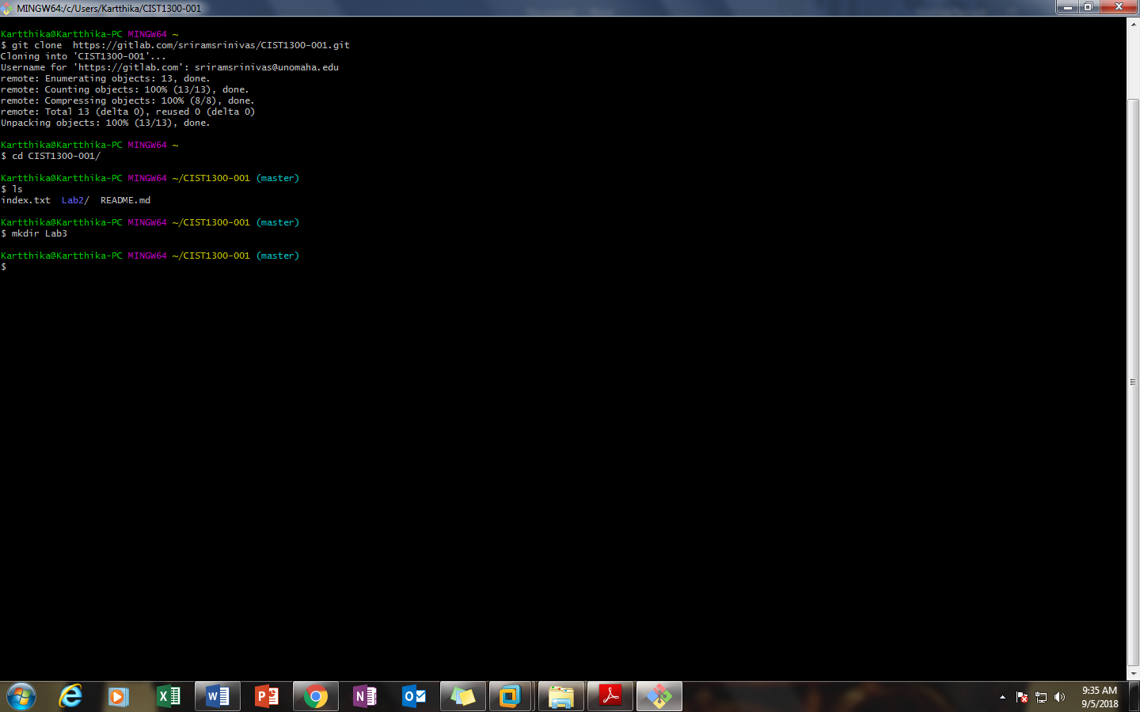

Step 5:- Now the let 's start writing code in Sublime, Launch sublime and let's sync our sublime. This is also a one-time setup. Now in sublime select File and choose an open folder, navigate to CIST1300-001 folder locally and select that folder. After yous elected your sublime should look something similar-

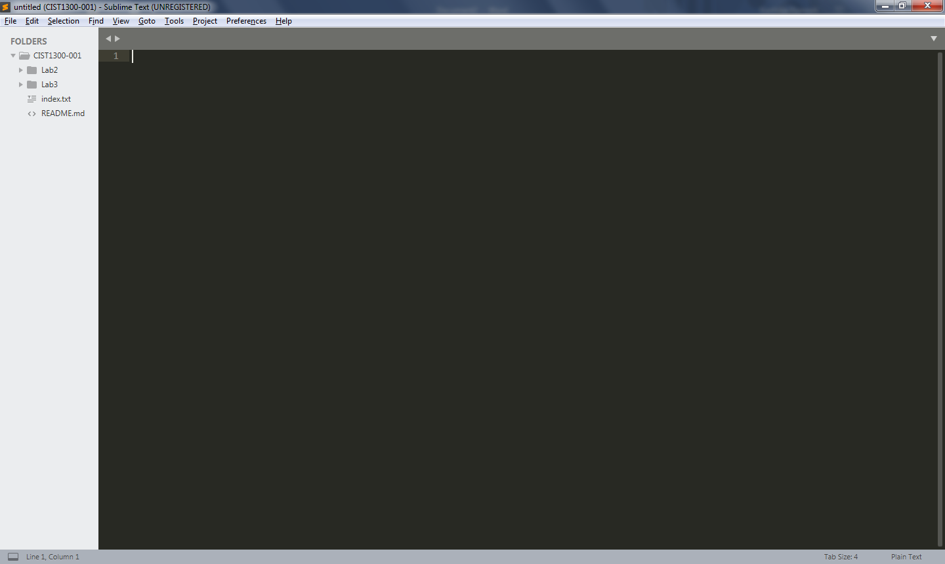

Step 6:- Don’t proceed unless you have completed step5. If you are having issues, talk with the instructor and he will help you. Now inside Lab3 folder in sublime create new file index.html. Make sure it is index.html, not Index.

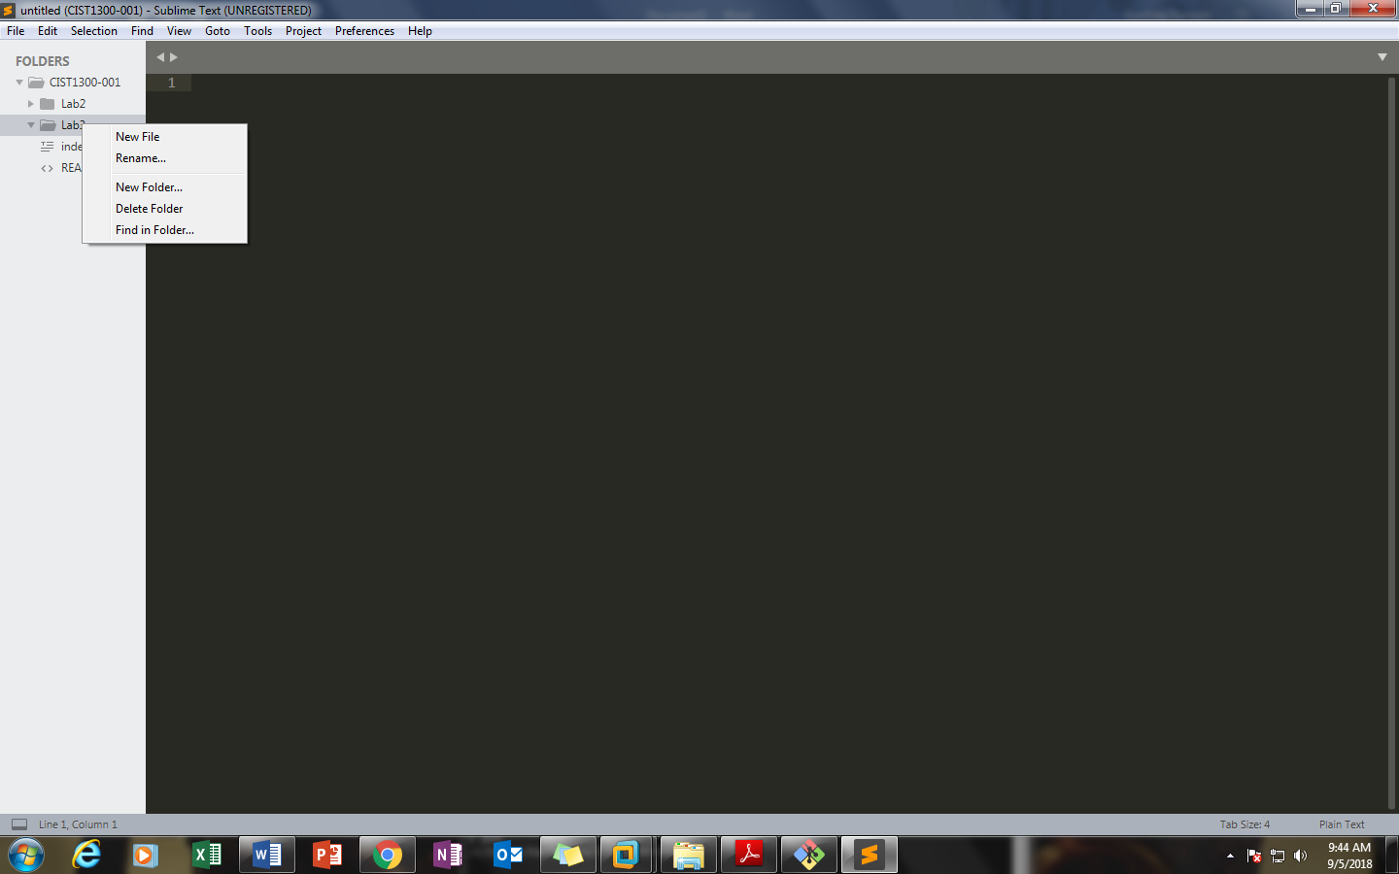

And save the new file.

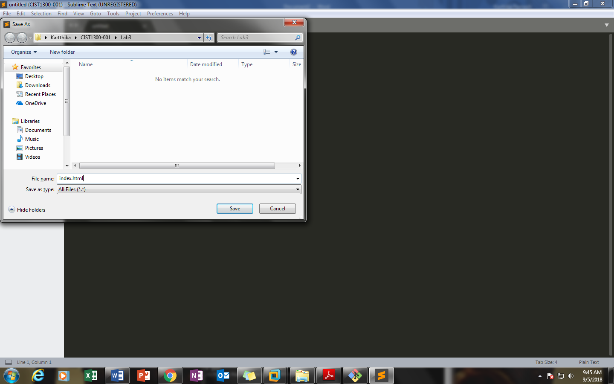

Step 7: Now get started and start writing your HTML code, Add image and tell about yourself. You can use the code from Lab2 as a reference. Please be creative, the goal is to use HTML elements we learned and apply HTML syntax correctly.

This lab consists of multiple sections, today I expect you to set up your local repo, start your first page, and create a link to the second page. The next section of the lab will be a continuation of this, so please complete this section of the lab before you proceed to Lab 2. If you are done early please start working on creating a new web page inside your Lab 3 folder, called resume.html and start working on it.